**Failure message:**

mkacct_tools.PushToCluster: "/opt/fedex/mkacct/bin/PushToCluster -qN 3_4800-unit" failed with 121

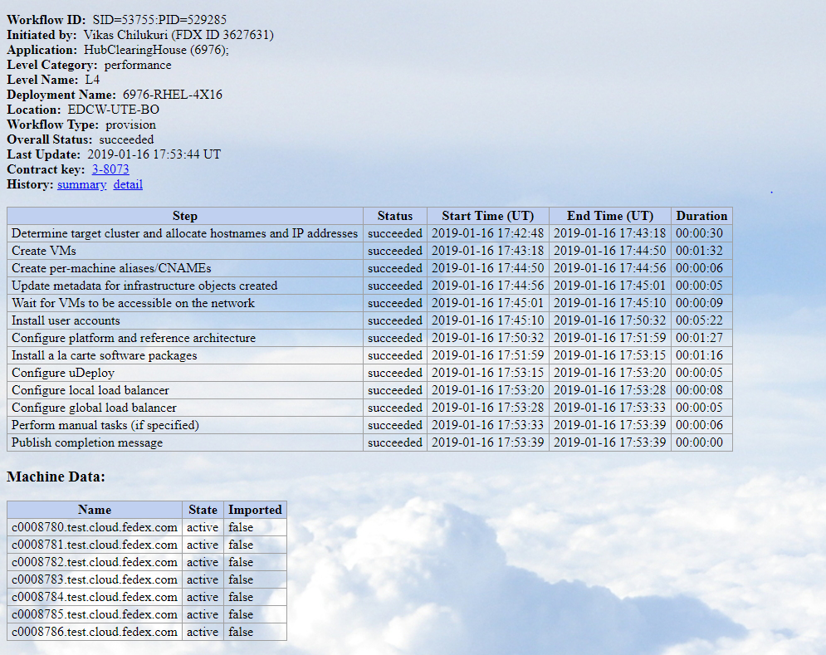

Check the servers in the putty if every comes green. Cause the problem in the account services.

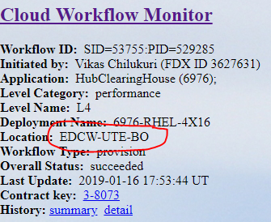

Depends on the location you find the services

Shared documents >> Environment Map >> [04_Prod server to service map](http://team.web.fedex.com/sites/itoadmin/cloudops/cloudteam/Shared%20Documents/Environment%20Map/04_Prod%20server%20to%20service%20map.xlsx) >> take services name > putty (services.test.cloud.fedex.com)

**In putty**

# cd path given in the error

# puchtocluster using the contract key

After pushing it to the cluster you can restart the workflow.

If it shows further errors like:

Xxxxxxxx services in the not responding

Then you need to restart the services from the cloudops

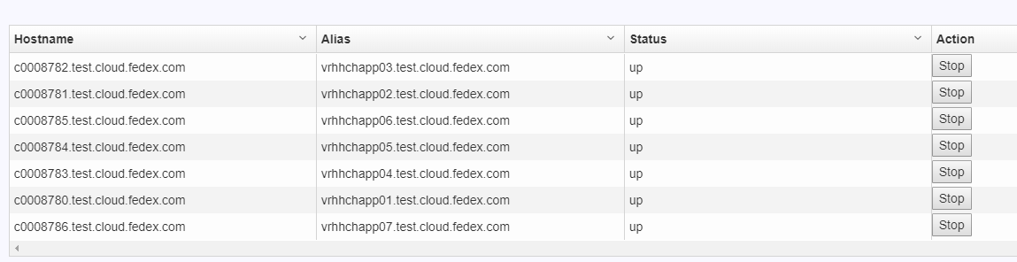

Screech for the services name **>>** view **>>** machine details **>>** stop the services that giving the problem

No space left on device

Check the server for low space folder. If needed delete (contact the runner for fee up space in the /home folder) the files in the folder to fee up some space.